LABORATORY CHAPTER №2
- NUMERAL SYSTEMS
A numeral system (or Digital Number System) is a writing system for expressing numbers; that is, a mathematical notation for representing numbers of a given set, using digits or other symbols in a consistent manner. It can be seen as the context that allows the symbols "11" to be interpreted as the binary symbol for three, the decimal symbol for eleven, or a symbol for other numbers in different bases.
A digital system can understand positional number system only where there are a few symbols called digits and these symbols represent different values depending on the position they occupy in the number. A value of each digit in a number can be determined using:
- The digit
- The position of the digit in the number
- The base of the number system (where base is defined as the total number of digits available in the number system).
As a computer programmer or an IT professional, you should understand the following number systems which are frequently used in computers.
S.N. | Number System & Description
1 | Binary Number System  Base 2. Digits used: 0, 1
2 | Octal Number System  Base 8. Digits used: 0 to 7
3 | Hexadecimal Number System  Base 16. Digits used: 0 to 9, Letters used: A- F

Table corresponding to the first 17 positive integers basic of number systems

Decimal | Binary | Octal | Hexadecimal
0 | 0 | 0 | 0
1 | 1 | 1 | 1
2 | 10 | 2 | 2
3 | 11 | 3 | 3
4 | 100 | 4 | 4
5 | 101 | 5 | 5
6 | 110 | 6 | 6
7 | 111 | 7 | 7
8 | 1000 | 10 | 8
9 | 1001 | 11 | 9
10 | 1010 | 12 | A
11 | 1011 | 13 | B
12 | 1100 | 14 | C
13 | 1101 | 15 | D
14 | 1110 | 16 | E
15 | 1111 | 17 | F
16 | 10000 | 20 | 10

Decimal Number System
The number system that we use in our day-to-day life is the decimal number system. Decimal number system has base 10 as it uses 10 digits from 0 to 9. In decimal number system, the successive positions to the left of the decimal point represents units, tens, hundreds, thousands and so on.
Each position represents a specific power of the base (10). For example, the decimal number 1234 consists of the digit 4 in the units position, 3 in the tens position, 2 in the hundreds position, and 1 in the thousands position, and its value can be written as
(1×1000) + (2×100) + (3×10) + (4×l)
(1×10³) + (2×10²) + (3×10¹) + (4×l0⁰)
1000 + 200 + 30 + 4= 1234

Binary Number System
Characteristics
- Uses two digits, 0 and 1.
- Also called base 2 number system
- Each position in a binary number represents a 0 power of the base (2). Example: 2⁰
- Last position in a binary number represents an x power of the base (2). Example: 2^{x} where x represents the last position - 1.
Example
Binary Number: 10101₂
Calculating Decimal Equivalent :
Step | Binary Number | Decimal Number
Step 1 | 10101₂ | ((1 × 2⁴) + (0 × 2³) + (1 × 2²) + (0 × 2¹) + (1 × 2⁰))₁₀
Step 2 | 10101₂ | (16 + 0 + 4 + 0 + 1)₁₀
Step 3 | 10101₂ | 21₁₀
Note: 10101₂ is normally written as 10101.

Octal Number System
Characteristics
- Uses eight digits, 0,1,2,3,4,5,6,7.
- Also called base 8 number system
- Each position in an octal number represents a 0 power of the base (8). Example: 8⁰
- Last position in an octal number represents an x power of the base (8). Example: 8^{x} where x represents the last position - 1.
Example
Octal Number − 12570₈
Calculating Decimal Equivalent:
Step | Octal Number | Decimal Number
Step 1 | 12570₈ | ((1 × 8⁴) + (2 × 8³) + (5 × 8²) + (7 × 8¹) + (0 × 8⁰))₁₀
Step 2 | 12570₈ | (4096 + 1024 + 320 + 56 + 0)₁₀
Step 3 | 12570₈ | 5496₁₀
Note: 12570₈ is normally written as 12570.

Hexadecimal Number System
Characteristics
- Uses 10 digits and 6 letters, 0,1,2,3,4,5,6,7,8,9,A,B,C,D,E,F.
- Letters represents numbers starting from 10. A = 10, B = 11, C = 12, D = 13, E = 14, F = 15.
- Also called base 16 number system.
- Each position in a hexadecimal number represents a 0 power of the base (16). Example 16⁰.
- Last position in a hexadecimal number represents an x power of the base (16). Example 16^{x} where x represents the last position - 1.
Example
Hexadecimal Number: 19FDE₁₆
Calculating Decimal Equivalent:
Step | Binary Number | Decimal Number
Step 1 | 19FDE₁₆ | ((1 × 16⁴) + (9 × 16³) + (F × 16²) + (D × 16¹) + (E × 16⁰))₁₀
Step 2 | 19FDE₁₆ | ((1 × 16⁴) + (9 × 16³) + (15 × 16²) + (13 × 16¹) + (14 × 16⁰))₁₀
Step 3 | 19FDE₁₆ | (65536 + 36864 + 3840 + 208 + 14)₁₀
Step 4 | 19FDE₁₆ | 106462₁₀
Note − 19FDE₁₆ is normally written as 19FDE.

Number System Conversion
There are many methods or techniques which can be used to convert numbers from one base to another.

Decimal to Other Base System
Steps:
Step 1 − Divide the decimal number to be converted by the value of the new base.
Step 2 − Get the remainder from Step 1 as the rightmost digit (least significant digit) of new base
number.
Step 3 − Divide the quotient of the previous divide by the new base.
Step 4 − Record the remainder from Step 3 as the next digit (to the left) of the new base number.

Step 5 - Repeat Steps 3 and 4, getting remainders from right to left, until the quotient becomes zero in Step 3. The last remainder thus obtained will be the Most Significant Digit (MSD) of the new base number.

Example
Decimal Number: 29₁₀
Calculating Binary Equivalent −
Step | Operation | Result | Remainder
Step 1 | 29 / 2 | 14 | 1
Step 2 | 14 / 2 | 7 | 0
Step 3 | 7 / 2 | 3 | 1
Step 4 | 3 / 2 | 1 | 1
Step 5 | 1 / 2 | 0 | 1
NOTE: As mentioned in Steps 2 and 4, the remainders have to be arranged in the reverse order so that the first remainder becomes the Least Significant Digit (LSD) and the last remainder becomes the Most Significant Digit (MSD). Decimal Number 29₁₀ = Binary Number − 11101₂.

Other Base System to Decimal System
- Step 1 − Determine the column (positional) value of each digit (this depends on the position of the digit and the base of the number system).
- Step 2 − Multiply the obtained column values (in Step 1) by the digits in the corresponding columns.
- Step 3 − Sum the products calculated in Step 2. The total is the equivalent value in decimal.
Example
Binary Number − 11101₂
Calculating Decimal Equivalent
Step | Binary Number | Decimal Number
Step 1 | 11101₂ | ((1 × 2⁴) + (1 × 2³) + (1 × 2²) + (0 × 2¹) + (1 × 2⁰))₁₀
Step 2 | 11101₂ | (16 + 8 + 4 + 0 + 1)₁₀
Step 3 | 11101₂ | 29₁₀
Binary Number − 11101₂ = Decimal Number 29₁₀

Other Base System to Non-Decimal System
Steps
- Step 1 − Convert the original number to a decimal number (base 10).
- Step 2 − Convert the decimal number so obtained to the new base number.
Example
Octal Number − 25₈
Calculating Binary Equivalent

Step 1 − Convert to Decimal
Step | Octal Number | Decimal Number
Step 1 | 25₈ | ((2 × 8¹) + (5 × 8⁰))₁₀
Step 2 | 25₈ | (16 + 5 )₁₀
Step 3 | 25₈ | 21₁₀
Octal Number − 25₈ = Decimal Number − 21₁₀

Step 2 − Convert Decimal to Binary
Step | Operation | Result | Remainder
Step 1 | 21 / 2 | 10 | 1
Step 2 | 10 / 2 | 5 | 0
Step 3 | 5 / 2 | 2 | 1
Step 4 | 2 / 2 | 1 | 0
Step 5 | 1 / 2 | 0 | 1
Decimal Number − 21₁₀ = Binary Number − 10101₂
Octal Number − 25₈ = Binary Number − 10101₂

Shortcut method - Binary to Octal
Steps
- Step 1 − Divide the binary digits into groups of three (starting from the right).
- Step 2 − Convert each group of three binary digits to one octal digit.
Example
Binary Number − 10101₂
Calculating Octal Equivalent
Step | Binary Number | Octal Number
Step 1 | 10101₂ | 010 101
Step 2 | 10101₂ | 2₈ 5₈
Step 3 | 10101₂ | 25₈
Binary Number − 10101₂ = Octal Number − 25₈

Shortcut method - Octal to Binary
Steps
- Step 1 − Convert each octal digit to a 3 digit binary number (the octal digits may be treated as decimal for this conversion).
- Step 2 − Combine all the resulting binary groups (of 3 digits each) into a single binary number.
Example
Octal Number − 25₈
Calculating Binary Equivalent
Step | Octal Number | Binary Number
Step 1 | 25₈ | 2₁₀ 5₁₀
Step 2 | 25₈ | 010₂ 101₂
Step 3 | 25₈ | 010101₂
Octal Number − 25₈ = Binary Number − 10101₂

Shortcut method - Binary to Hexadecimal
Steps
- Step 1 − Divide the binary digits into groups of four (starting from the right).
- Step 2 − Convert each group of four binary digits to one hexadecimal symbol.
Example
Binary Number − 10101₂
Calculating hexadecimal Equivalent −
Step | Binary Number | Hexadecimal Number
Step 1 | 10101₂ | 0001 0101
Step 2 | 10101₂ | 1₁₀ 5₁₀
Step 3 | 10101₂ | 15₁₆
Binary Number − 10101₂ = Hexadecimal Number − 15₁₆

Shortcut method - Hexadecimal to Binary
Steps
- Step 1 − Convert each hexadecimal digit to a 4 digit binary number (the hexadecimal digits may be treated as decimal for this conversion).
- Step 2 − Combine all the resulting binary groups (of 4 digits each) into a single binary number.
Example
Hexadecimal Number − 15₁₆
Calculating Binary Equivalent
Step | Hexadecimal Number | Binary Number
Step 1 | 15₁₆ | 1₁₀ 5₁₀
Step 2 | 15₁₆ | 0001₂ 0101₂
Step 3 | 15₁₆ | 00010101₂
Hexadecimal Number − 15₁₆ = Binary Number − 10101₂

Binary Arithmetic
Binary arithmetic is essential part of all the digital computers and many other digital system.
Binary Addition

It is a key for binary subtraction, multiplication, division. There are four rules of binary addition.
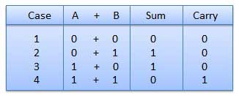
In fourth case, a binary addition is creating a sum of (1 + 1 = 10) i.e. 0 is written in the given column and a carry of 1 over to the next column.
Example − Addition
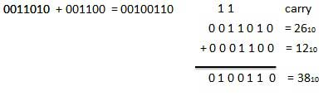

Binary Subtraction

Subtraction and Borrow, these two words will be used very frequently for the binary subtraction. There are four rules of binary subtraction.
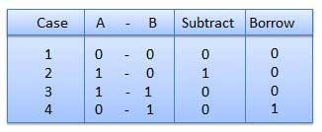
Example − Subtraction
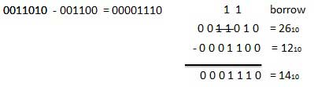

Octal Arithmetic
Following octal addition table will help you to handle octal addition.
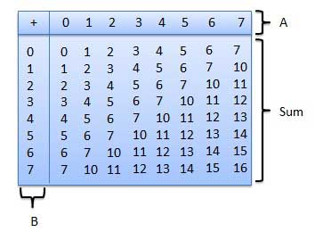
To use this table, simply follow the directions used in this example: Add 6₈ and 5₈. Locate 6 in the A column then locate the 5 in the B column. The point in 'sum' area where these two columns intersect is the 'sum' of two numbers 6₈ + 5₈ = 13₈.

Octal Addition
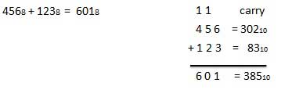

Octal Subtraction
The subtraction of octal numbers follows the same rules as the subtraction of numbers in any other number system. The only variation is in borrowed number. In the decimal system, you borrow a group of 10₁₀. In the binary system, you borrow a group of 2₁₀. In the octal system you borrow a group of 8₁₀.

Octal Subtraction
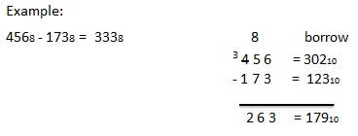

Hexadecimal Arithmetic

Hexadecimal Addition
Following hexadecimal addition table will help you greatly to handle Hexadecimal addition.
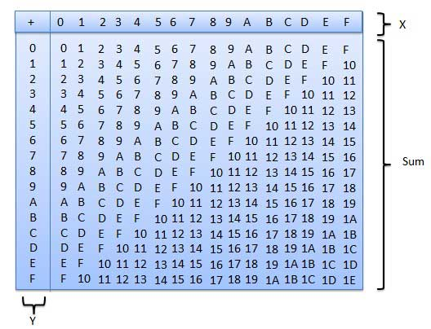
To use this table, simply follow the directions used in this example − Add A₁₆ and 5₁₆. Locate A in the X column then locate the 5 in the Y column. The point in 'sum' area where these two columns intersect is the sum of two numbers. A₁₆ + 5₁₆ = F₁₆.

Example − Addition
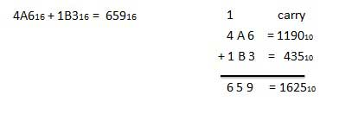

Hexadecimal Subtraction
The subtraction of hexadecimal numbers follow the same rules as the subtraction of numbers in any other number system. The only variation is in borrowed number. In the decimal system, you borrow a group of 10₁₀. In the binary system, you borrow a group of 2₁₀. In the hexadecimal system you borrow a group of 16₁₀.

Example - Subtraction
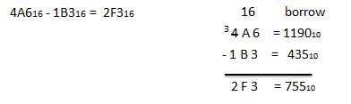

- HARDWARE OF COMPUTERS
Computer systems are made up of hardware and software. Computer hardware is made up of the parts of the computer that you can touch: its physical components. Software is the programs, instructions and data that controls the operation of a computer and enables the computer to carry out a task.

Software
There are two types of software that are used to operate a computer.
System software. These are programs and files that make up the computer’s operating system. Examples of system software include the software to connect with the printer, that controls the way the screen appears, the software that deletes a file or a folder. These run invisibly in the background so that you can do your work effectively.
Applications software. Also known as applications programs. These programs allow users to write letters, solve problems, perhaps using spreadsheet and database software, or to play games. If you look at your computer screen, you should see that there are many different kinds of applications software. You might see examples of the following software (you are likely to have many more):
- word processing
- presentation software
- modeling software – spreadsheets
- data-handling software – databases
- desktop publishing
- video editing software
- apps

Hardware
When you look at a computer and all the peripheral devices that are attached to it, you can see examples of hardware such as:
- monitor
- keyboard
- mouse
- printer
- speakers
- scanner
Some peripheral devices have more than one function. Many people now choose to have their scanner, photocopier and printer together in one device, which are widely known as All-In-One printers. Touch-sensitive screens allow us to use them as input devices as well as output devices. Having an external hard drive is an excellent way of giving yourself extra portable storage space as well as providing a backup facility.
Of course, there are other examples besides the hardware that can actually be seen. There is other hardware that is built into, or inside the computer case (or tower) including
- Memory chips
- Processing chips
- A motherboard
- Video cards (note the connection sockets such as VGA, HDMI, DVI)
- Sound cards (note the sockets for such hardware as headphone and microphone)
- Internal hard disk drive
There is also computer hardware in devices like mobile phones, satellite navigation systems, automatic washing machines and even in car engines.
Computer systems also include a processor and memory. Computer systems are made up of many devices. Some devices, such as keyboards and scanners, are used to input data to a computer. Other devices, such as a printer or speakers, are needed so that we can understand the output from a computer.
Peripheral devices such as these provide data for the processor or central processing unit (CPU) to work with and then to communicate the results of that processing. Without a processor there would be no computer system, the data you entered would have nothing done with it – no processing would have taken place.

Motherboard
A motherboard (sometimes known as the mainboard or system board) is the main circuit board found in a computer. It holds the crucial electronic components of the system, such as the processor (CPU) and main memory. It also provides connectors for other peripherals such as video and sound cards, and USB devices such as a mouse. The non-volatile memory that holds the system BIOS will also be directly attached to the motherboard. This is true not just for your
desktop computer but also laptop/tablet and even your mobile phone. If the processor is the ‘brain’ of the system, then the motherboard is certainly the ‘spine’ onto which all other devices are connected.

Processor – Central Processing Unit (CPU)
The processor is at the centre of a system, between input, output and storage devices, and is known as the Central Processing Unit (CPU). The processor:
- interprets and executes commands from the computer’s hardware and software
- is a single integrated circuit, also found in many devices that involve control and monitoring (like an engine management system in a car, or the automatic stopping systems in trains).

Main memory
The main memory of the computer stores all the data and instructions that enable the computer to function. There are other names for the main memory: internal memory/central memory/primary memory. There are two types of main memory RAM and ROM:
RAM (Random Access Memory) is an internal memory chip where data is stored temporarily when applications are running. If your program is large, such as Word or Photoshop, you might notice that it takes a while to load. This is because it is being brought from your computer’s hard drive (where it is stored) into RAM. From here the processor can rapidly respond to instructions, as the program is immediately accessible in RAM.
● RAM can be both read and written to.
● RAM is volatile (temporary), because its contents are lost when the power is turned off.

ROM (Read Only Memory) stores data or instructions that need to be permanent. Permanent memory is used to store the processes that the computer needs to go through when it is switched on. ROM retains its contents when the power is switched off.It is also known as non-volatile or permanent memory. An important use of ROM is to store the software that allows a machine to start up successfully. This software is known as BIOS, or Basic Input and Output System, and it loads and runs the boot file (the start-up instructions). When the computer is switched on, BIOS starts the boot file sequence, which:
- checks that all the hardware devices are attached and are working properly
- copies the operating system to the RAM
- stores the date, time and system configuration on a battery-powered non-volatile chip known as a CMOS (a Complementary Metal Oxide Semiconductor).

How does computer works?
For successful "communication" with a computer, it is harmful to perceive it as a black box that is about to give out something unexpected. To understand the reaction of the computer to your actions, you need to know what are its main components and how do they works.
A computer stores, transmits and processes absolutely all kinds of information in the form of "0" and "1", i.e. it uses binary code and binary numeric system. In this form stored all the data that must be processed, and all the programs that control the processing.
When information is entered into a computer (with the help of input devices, removable storage or via internet), it is stored on a special data storage device - hard (magnetic) disk drive (HDD). This device is called a hard disk because of its construction. Inside there are one or more solid pancakes (metal or glass), on which stores all the data (text documents, photos, films, etc.) and installed programs (operating system, application programs, etc.).
The main task of a computer is to process information, that is, to perform calculations. Most of the calculations are performed by a special device - the central processor unit. It is a complex chip containing hundreds of millions of elements (transistors). Depending on what instructions the running program sends to the processor at a given time, it indicates what data needs to be processed and what needs to be done with it.
Programs and data are loaded from the drive (HDD). But the hard disk is a relatively slow device, and if the processor waited for the information to be read and then recorded back after processing, it would remain idle for a long time. RAM speeds up processor access to programs and data. All necessary programs and data are read into RAM in advance from the hard disk. During operation, the processor accesses the RAM, reads the instructions of the program, which tells what data is needed to take and how to process it.
In order for all the listed components to interact with each other, they are placed on a single motherboard. The motherboard is the main hardware element of the computer, which has connectors for installing additional expansion cards and it serves as the mechanical basis for the entire electronic circuitry of the computer.

